**B.M.S. COLLEGE OF ENGINEERING**

**(Autonomous Institute, Affiliated to VTU)**

**Bull Temple Road, Basavanagudi, Bangalore - 560019**

A project report on

***“Static Website on Game Store”***

Submitted in partial fulfillment of the requirements for the award of degree

Bachelor of Engineering

In

Artificial Intelligence and Data Science

*Submitted by:*

|  |  |
| --- | --- |
| **Name** | **USN Number:** |
| **Sai Pramod B** | **1BM22AD049** |
| **Aditya Agarwal** | **1BM22AD003** |
| **M Yashwanth Reddy** | **1BM22AD035** |

Under the guidance of

**Designation**

**Department of Artificial Intelligence & Data Science**

A.Y 2022-23

|  |  |
| --- | --- |
|  | **B.M.S. COLLEGE OF ENGINEERING**  **(Autonomous Institute, Affiliate to VTU)**  **Bull Temple Road, Basavanagudi, Bangalore – 560019** |
| **Department of Artificial Intelligence & Data Science** | |

**C E R T I F I C A T E**

This is to certify that the group project entitled “Static Website on Game store” is a bona-fide work carried out by **(1BM22AD003) Aditya Agarwal, (1BM22AD049) Sai Pramod B**, & **(1BM22AD035) M. Yashwanth Reddy** in partial fulfillment for the award of degree of B.E in Artificial Intelligence and Data Sciencefrom **Visvesvaraya Technological University, Belgaum** during the year **2022-23**. The group project report has been approved as it satisfies the academic requirements in respect of group project prescribed for the Degree.

##### Signature of the Guide Signature of the HOD

**Name and Designation Name and Designation**

Table of Contents

Chapter 1 1

Introduction of the Website 1

Chapter 2 2

Website Modules Description 2

1. Website Overview Page: 2

2. Subpages: 2

Chapter 3 3

Tools Used 3

• HTML tags used and its working 3

• HTML Attributes and its working: 4

# Chapter 1

## Introduction of the Website

Welcome to our online game store, your virtual gateway to a world of extraordinary gaming experiences. Designed and developed as part of our AAT using HTML, CSS, and JavaScript, our static website aims to immerse you in the captivating realm of video games. Within this realm, you will find a curated assortment of games, tailored to cater to diverse tastes and preferences, ensuring that every gamer can find their perfect match.

The purpose of our online game store is to provide a seamless and user-friendly platform for gamers to indulge in their passion. With a sleek and intuitive interface, navigating through our website is a breeze, allowing you to effortlessly discover new titles or revisit old favorites. Our collection encompasses a wide range of genres, from action-packed adventures to strategic puzzles, from immersive RPGs to thrilling sports simulations. There is something for every kind of gamer, whether you're a casual player looking for a quick gaming fix or a dedicated enthusiast seeking an epic gaming journey.

In addition to offering an extensive selection of games, our website also incorporates features that enhance your overall gaming experience. You can read detailed game descriptions, watch trailers, and even access user reviews to make informed decisions before making a purchase. We value your feedback and encourage you to share your experiences with the gaming community, fostering a sense of camaraderie among fellow gamers.

Moreover, our online game store is committed to ensuring a secure and seamless transaction process. With multiple payment options available, you can choose the method that suits you best, and rest assured that your personal information is protected.

As a static website developed for our AAT, our online game store serves as a testament to the power of creativity and innovation in the world of web development. It showcases the foundational skills and knowledge in HTML, CSS, and JavaScript that have been honed through the course. This project not only showcases the technical proficiency in web development but also demonstrates an understanding of user experience and functionality.

# Chapter 2

## Website Modules Description

In this chapter, we will provide a detailed description of the various modules that constitute our online game store website. These modules play a crucial role in enhancing the functionality and user experience of the website.

### Website Overview Page(Home Page):

**STARLIGHT GAMES**

The website overview page serves as the central hub where users can get a comprehensive view of the website's offerings. It provides a visually appealing and intuitive interface that allows users discover new games. The website overview page showcases featured games.

It aims to provide a captivating introduction to the wide range of games available on the platform.

### Subpages:

Apart from the website overview page, our online game store website consists of various subpages that cater to specific functionalities and information. These subpages include:

#### Community Page:

This page gives an insight about the Community of StarLight Games. It contains some information about what the community offers.

It has an option to select a community to join using drop-down menu.

#### Contact Us Page:

This page gives an insight about how can we contact StarLight games. It has form which can be used to enter details.

The details are Name, E-Mail, Mobile Number, and a message section where we can give the queries and feedback or any related stuff included with submit button.

By providing detailed descriptions of these website modules, we aim to give readers a comprehensive understanding of the functionalities that make our online game store website both user-friendly and engaging.

The design and layout of these modules have been carefully crafted to ensure an immersive and seamless gaming experience for our users.

# Chapter 3

## Tools Used

## Files created:

## HTML pages:

## Main Page

## 8 pages for each game

## Community page

## Contact Us page

## 1 CSS file

## Java Script file

### HTML tags used and its working

* <!DOCTYPE html>: Declares the document type and version of HTML being used (HTML5).
* <html lang="en">: Defines the root element of an HTML document and specifies the document's language as English (en).
* <head>: Contains metadata about the HTML document, such as the title, links to external resources, and scripts.
* <title>: Sets the title of the HTML document, which appears in the browser's title bar or tab.
* <link>: Links external resources, such as stylesheets (CSS) and icons. It defines the relationship between the current document and the linked resource.
* <script>: Includes JavaScript code or references an external JavaScript file to add interactivity to the web page.
* <body style="margin: 0;">: Defines the main content of the web page and sets inline CSS to remove margin space.
* <nav class="nav">: Defines a navigation section of the web page with the CSS class "nav."
* <a>: Creates hyperlinks to other web pages or resources.
* <img>: Embeds images in the web page.
* <p>: Represents a paragraph of text.
* <button>: Creates clickable buttons.
* <br>: Inserts a line break to create vertical spacing.
* <h1>: Defines a top-level heading with the largest font size.
* <div>: Defines a generic container for grouping and styling elements.
* <footer>: Marks the footer section of the web page, typically containing information about the website or contact details.
* <ul>: Defines an unordered (bulleted) list.
* <li>: Represents list items within an ordered or unordered list.

### CSS attributes used and its working: -

### background-color: Specifies the background color of an element.

### color: Sets the text color.

### font-family: Defines the font family or typeface to be used for text.

### margin: Sets the margins around an element for spacing.

### float: Determines how an element should float within its container.

### vertical-align: Sets the vertical alignment of inline or inline-block elements.

### text-align: Defines the horizontal alignment of text within an element.

### border: Specifies the border of an element.

### cursor: Defines the mouse cursor appearance when hovering over an element.

### transition: Specifies a transition effect on an element, allowing smooth changes over a specified duration.

### position: Sets the positioning of an element (e.g., relative, fixed).

### width: Sets the width of an element.

### height: Sets the height of an element.

### border-radius: Specifies the radius of rounded corners for an element.

### background-image: Sets a background image for an element.

### background-size: Defines how a background image should be sized.

### background-repeat: Specifies whether a background image should repeat.

### display: Determines how an element should be displayed (e.g., flex, inline-block).

### align-items: Defines how flex items are aligned along the cross-axis.

### justify-content: Specifies how flex items are distributed along the main-axis.

### text-decoration: Sets text decorations, such as underlines or overlines.

### transform: Applies a transformation to an element, such as scaling or rotating.

**Java Script:-**

1. Event Listener for DOM Content Load

* document.addEventListener("DOMContentLoaded", () => { ... }): Listens for the DOMContentLoaded event, which fires when the initial HTML document has been completely loaded and parsed.

1. Variable Declarations

* const plus = document.querySelector(".increment");: Selects the HTML element with the class "increment" and assigns it to the constant variable plus.
* const minus = document.querySelector(".decrement");: Selects the HTML element with the class "decrement" and assigns it to the constant variable minus.
* const quantity = document.querySelector(".quantity");: Selects the HTML element with the class "quantity" and assigns it to the constant variable quantity.
* const atc = document.querySelector(".atc");: Selects the HTML element with the class "atc" and assigns it to the constant variable atc.
* const cart = document.querySelector(".cart");: Selects the HTML element with the class "cart" and assigns it to the constant variable cart.
* let a = 1;: Initializes a variable a with the value 1.
* let b = parseInt(localStorage.getItem('cartValue')) || 0;: Retrieves the value associated with the key 'cartValue' from localStorage, converts it to an integer using parseInt, or defaults to 0 if the value is not available.

1. Update Cart Value Display

* cart.innerText = b;: Updates the inner text of the cart element to display the current cart value.

1. Event Listeners for Buttons

* plus.addEventListener("click", () => { ... }): Listens for a click event on the plus button and increments the a variable and updates the quantity display accordingly.
* minus.addEventListener("click", () => { ... }): Listens for a click event on the minus button, decrements the a variable (if greater than 1), and updates the quantity display accordingly.
* atc.addEventListener("click", () => { ... }): Listens for a click event on the "Add to Cart" button, updates the cart value and localStorage, and reflects the changes in the cart display.

1. Game Information

* const productId = "spiderman2";: Defines a unique identifier for the game product.
* const gameInfo = { ... }: Defines an object containing information about the game, including title, price, quantity, and image URL.

1. Store Game Info in Local Storage

* localStorage.setItem(game_${productId}, JSON.stringify(gameInfo));: Stores the game information in localStorage using the unique identifier as the key, after converting the object to a JSON string.

**Code:**

1. 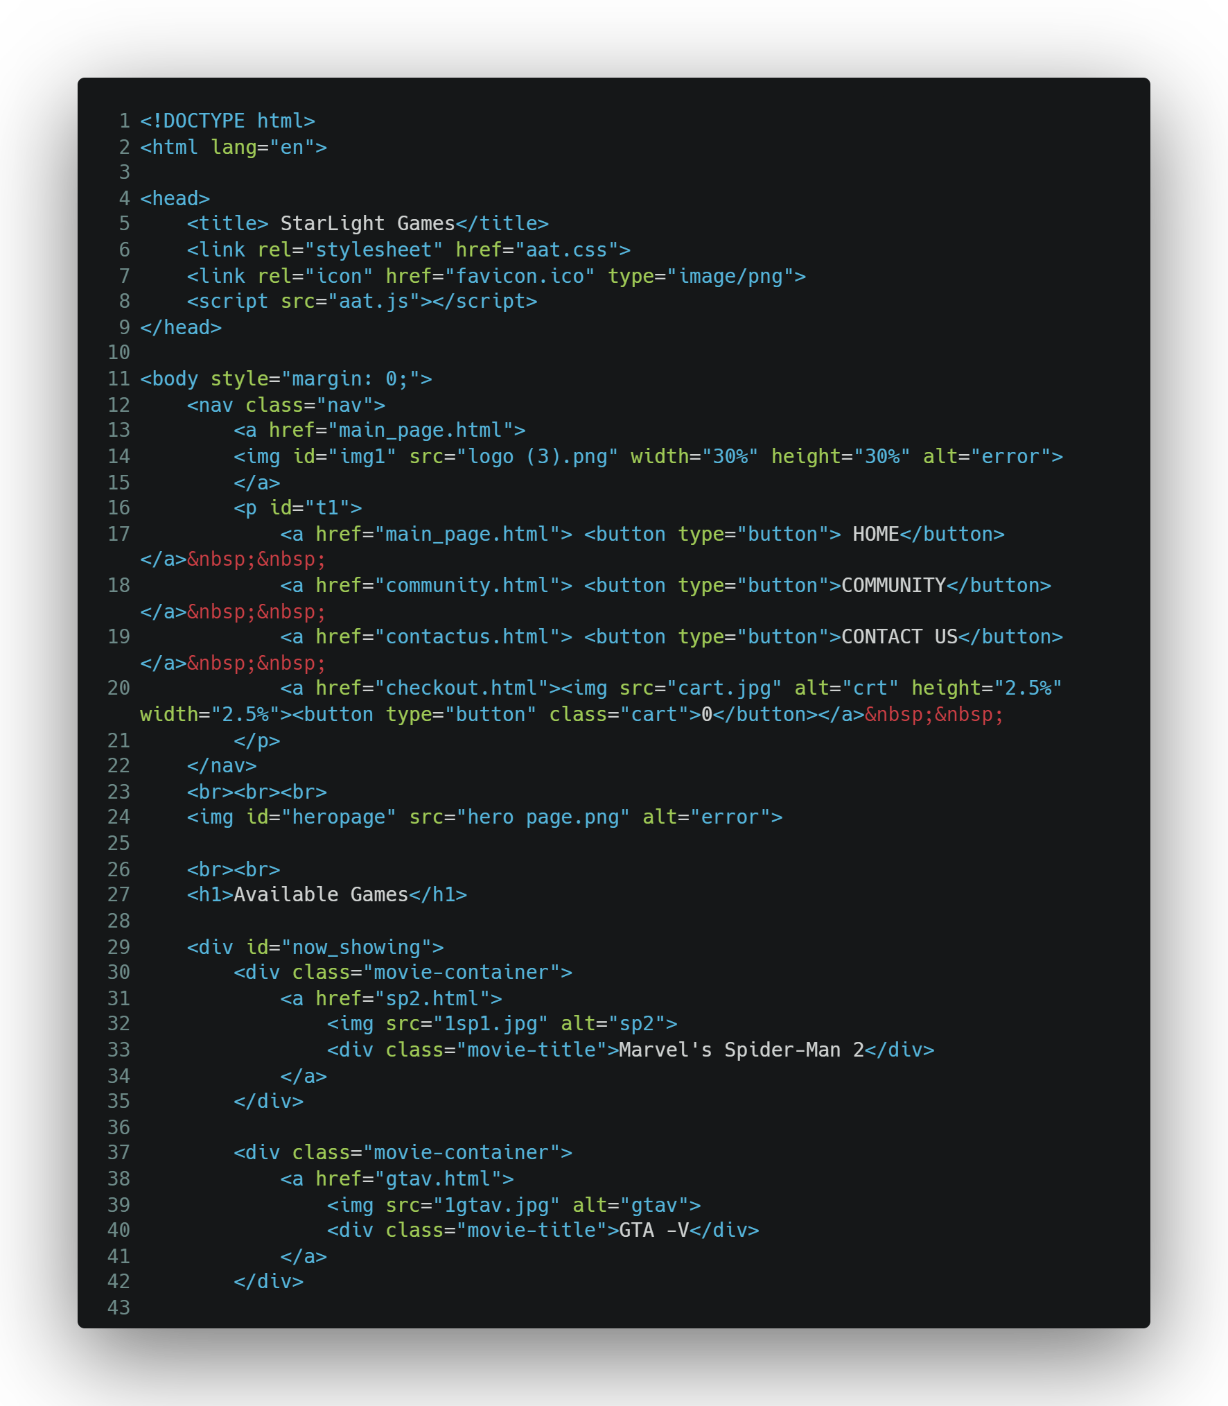**main_page.html**

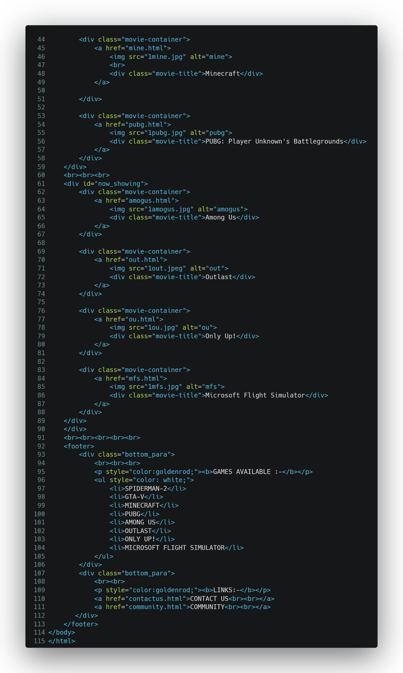

1. 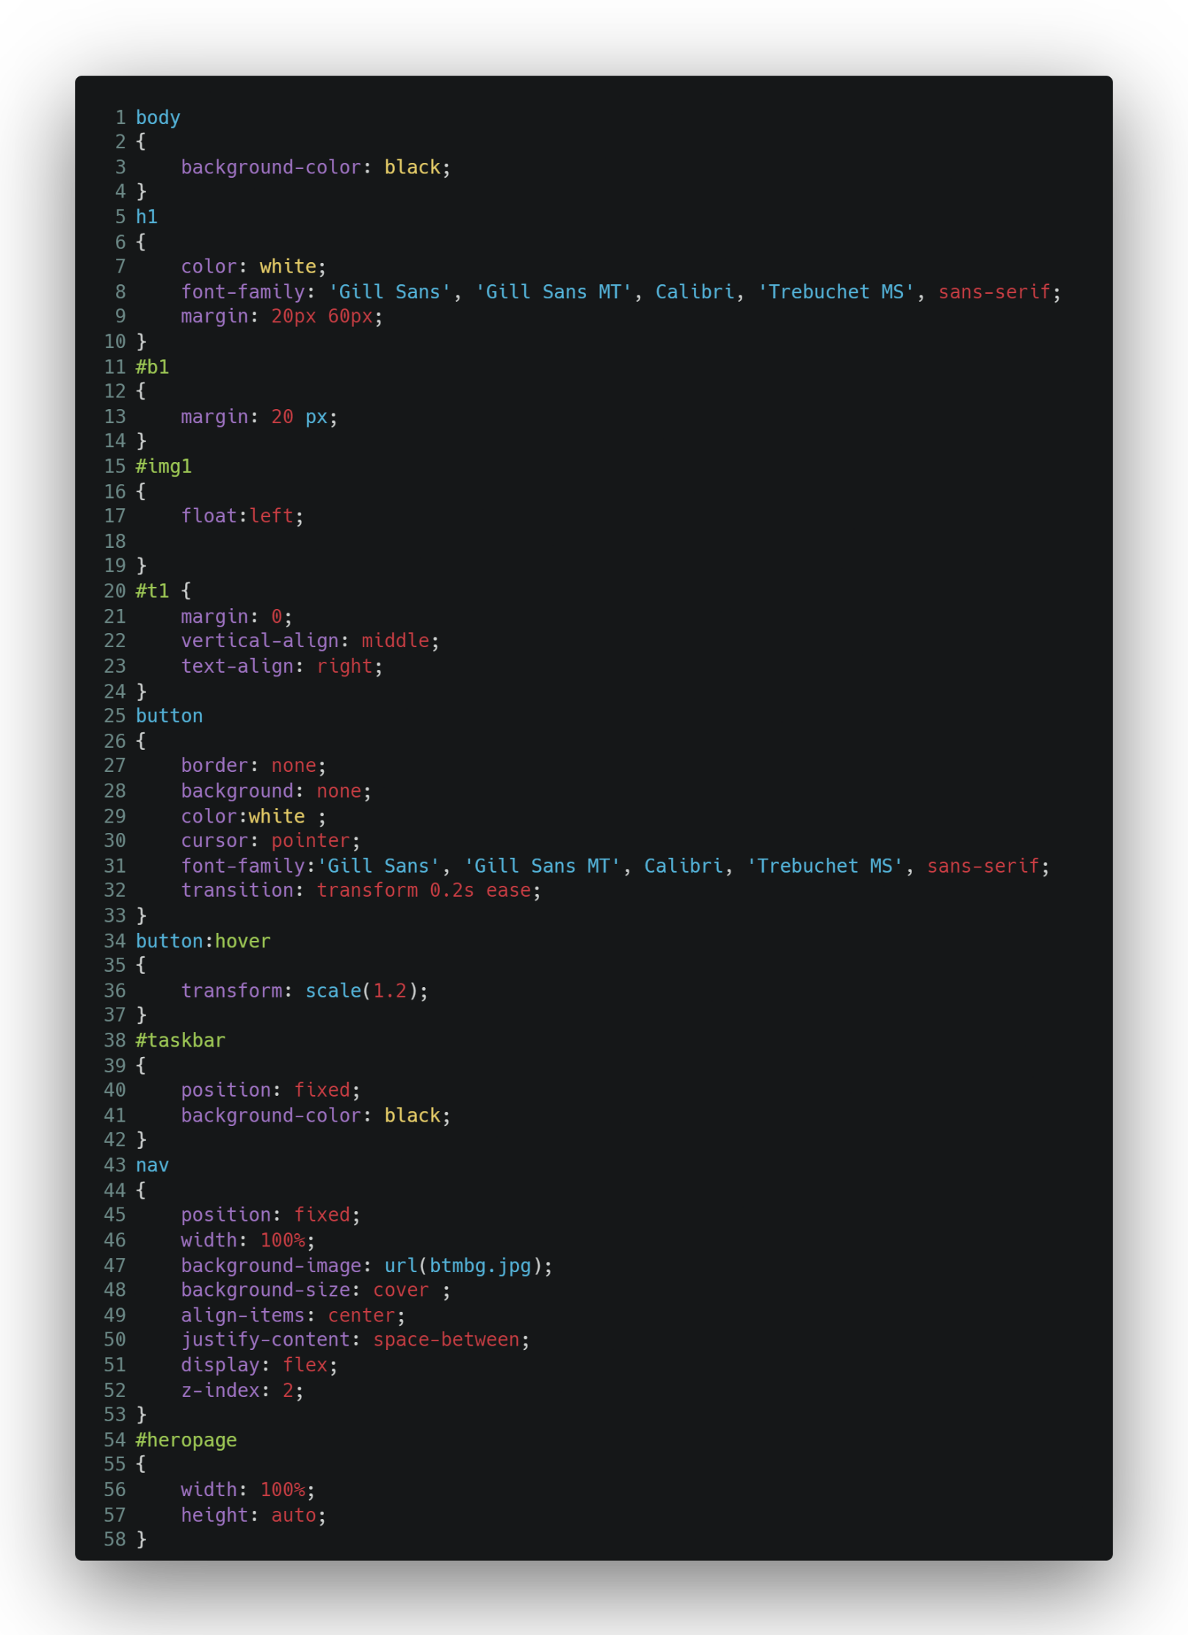**CSS code(AAT.css)**

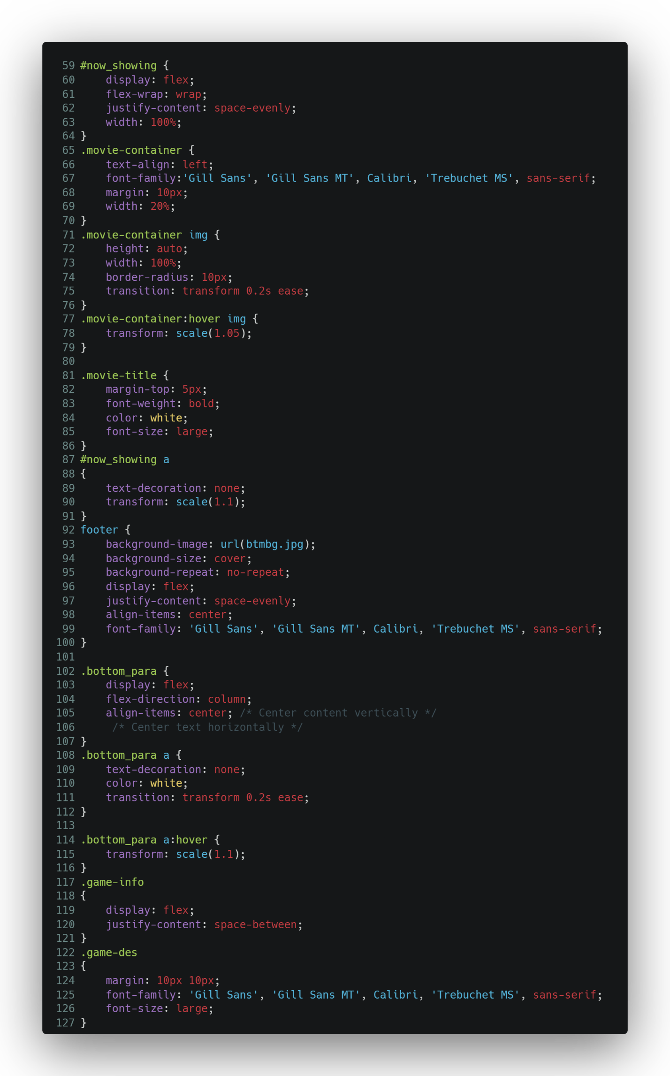

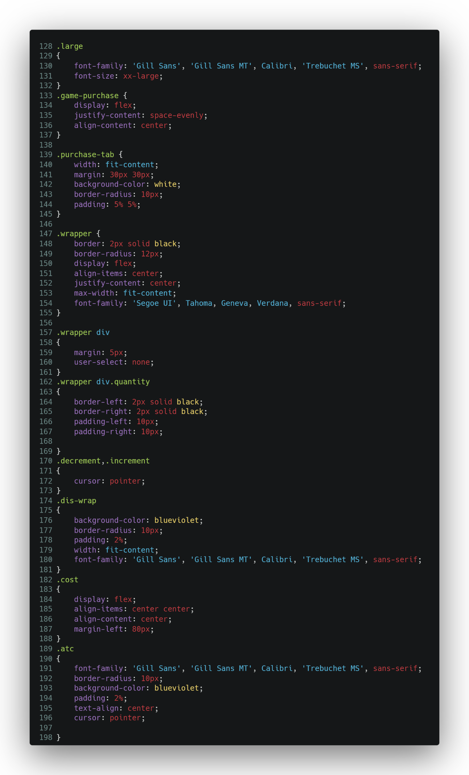

1. 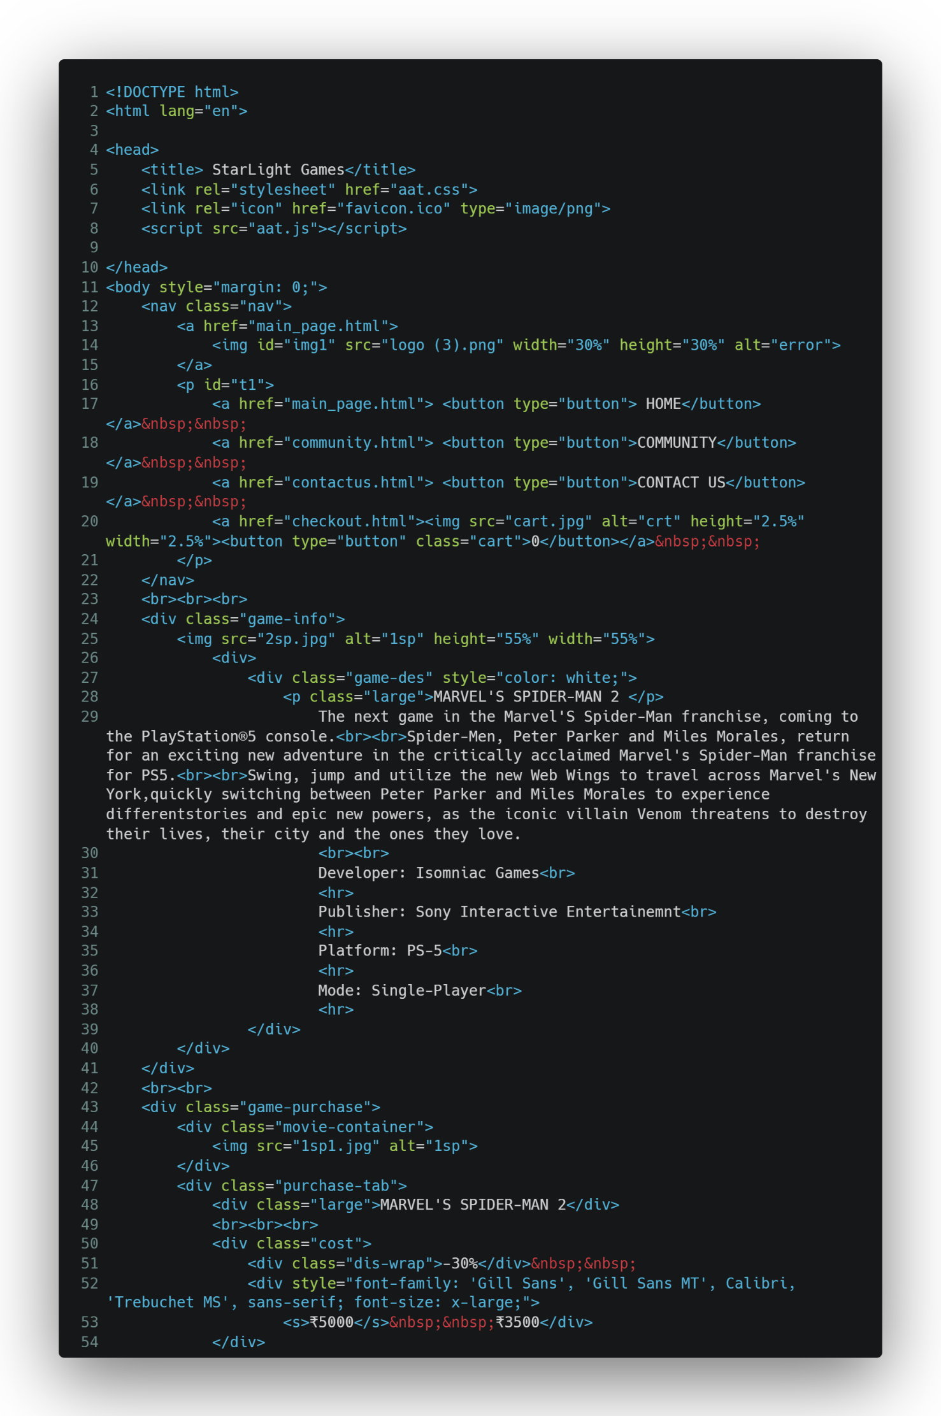**Game Page**

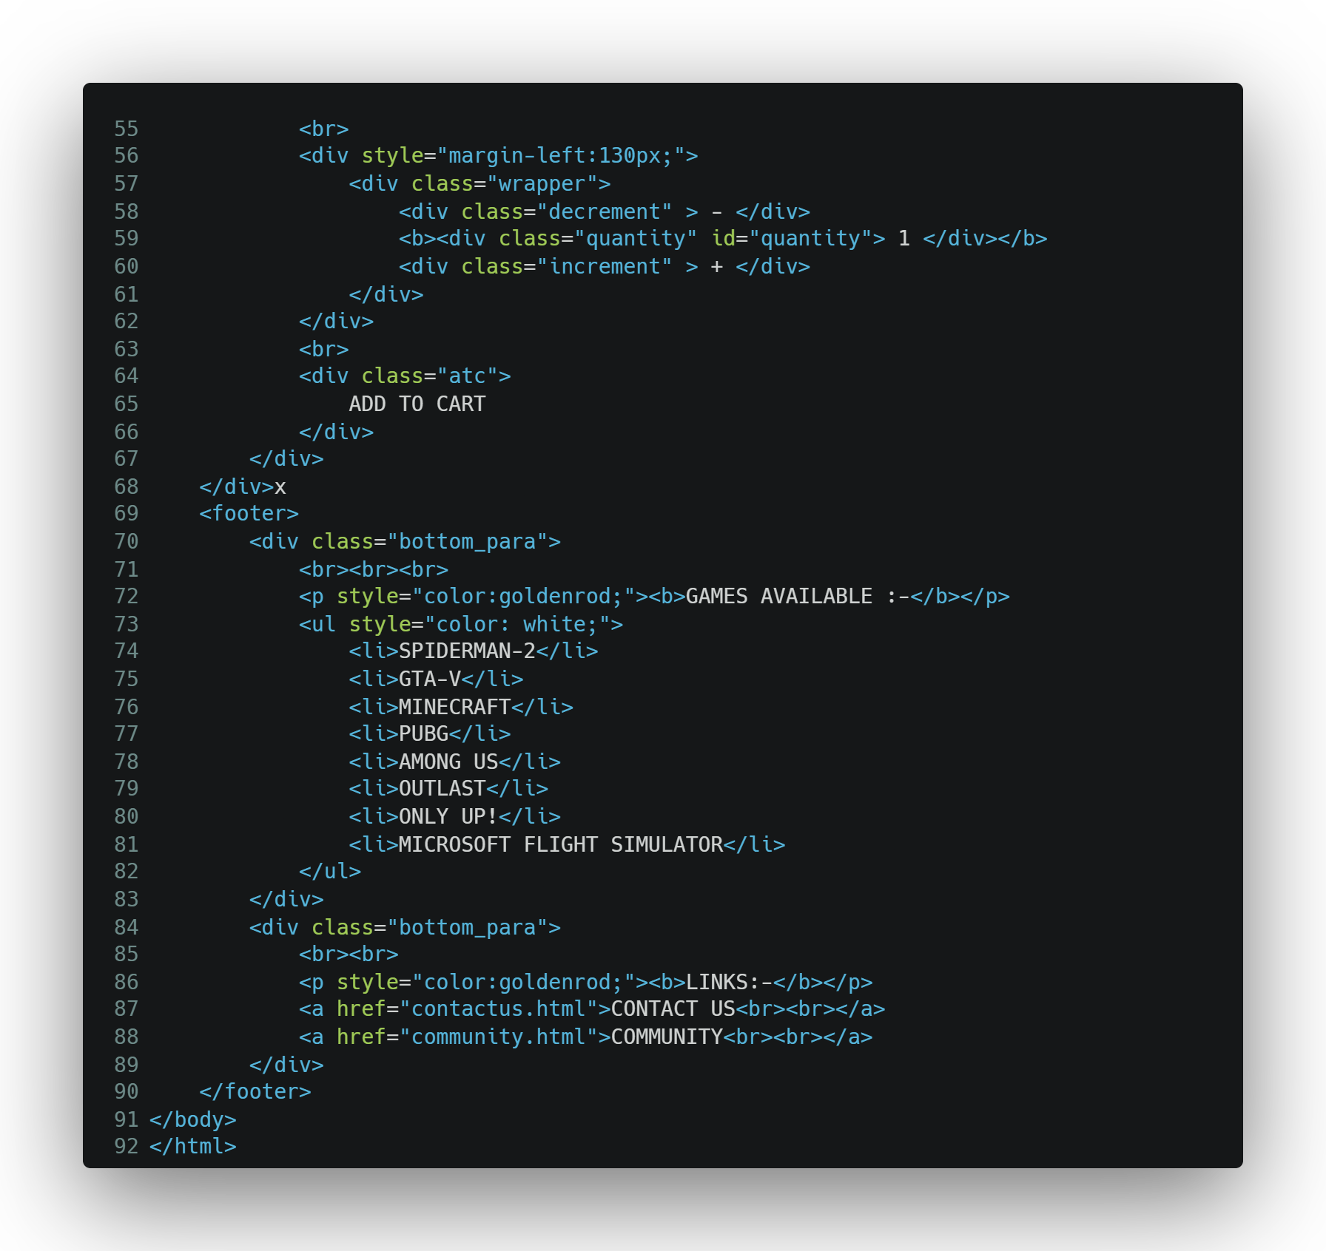

1. 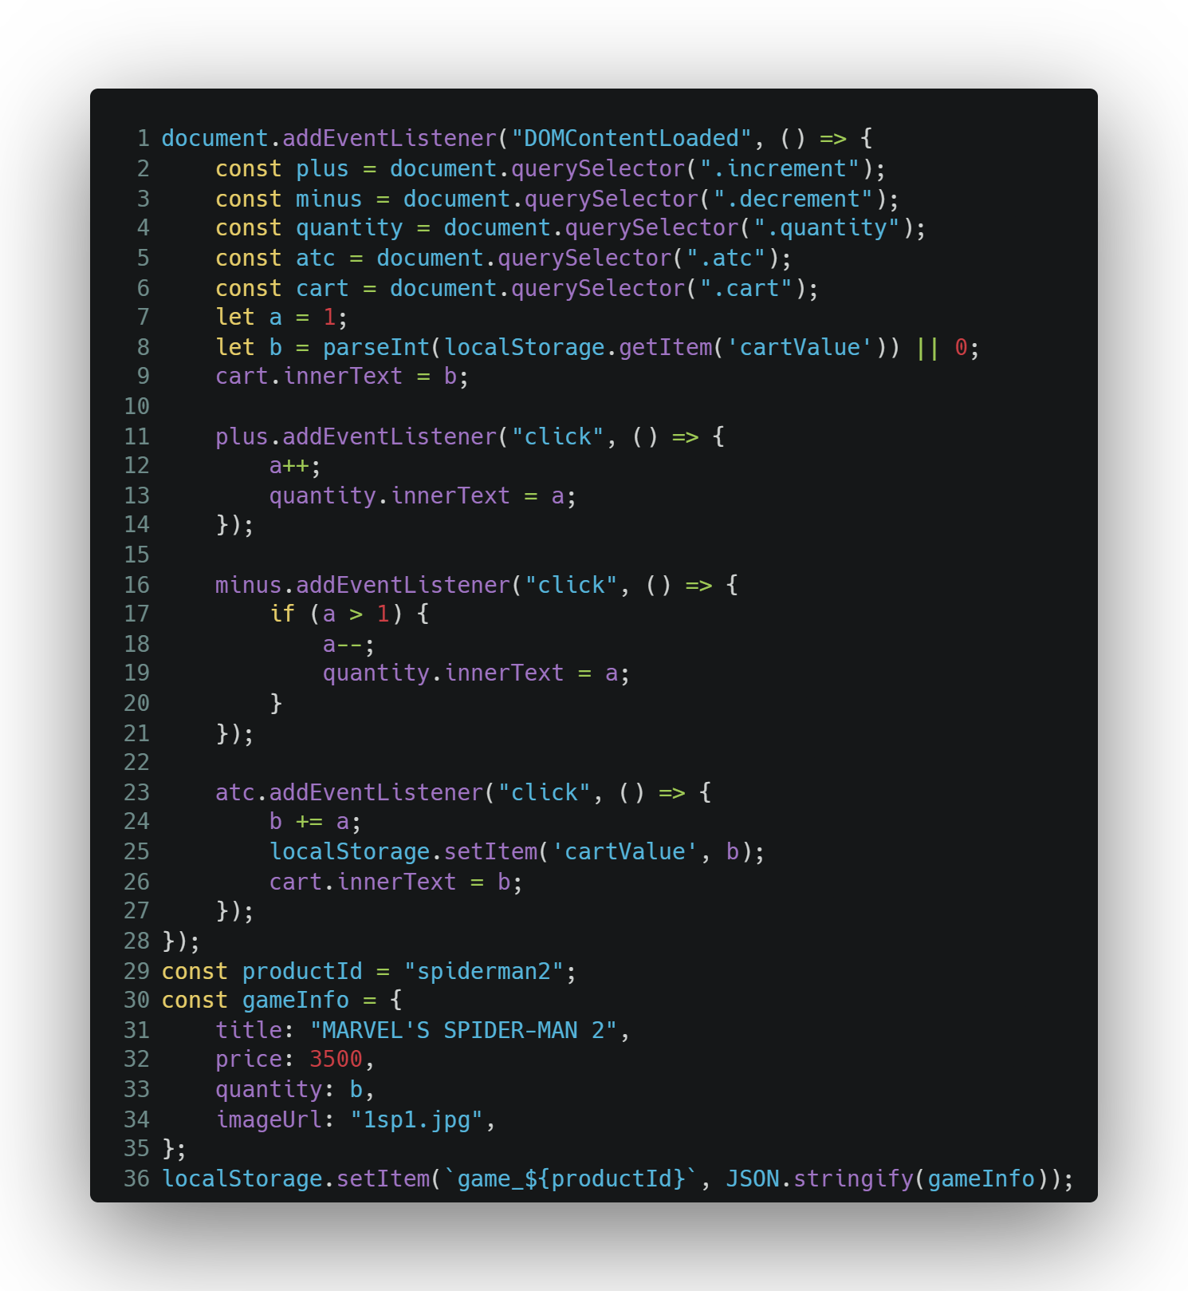**Java Script**

**Screenshots of Website:**

